VISHWAKARMA UNIVERSITY
Academic Year: 2025-26 | Semester II
ADVANCED WEB TECHNOLOGY
NAME OF THE STUDENT : | Aaditya Dhanwate
DEPARTMENT : | ARTIFICIAL INTELLIGENCE & DATA SCIENCE
CLASS / DIV. : | TY / A
SRN : | 31230319
ROLL NO. : | 8

ASSIGNMENT NO.: 09
Develop an Angular Application that Pulls Data from an Express.js API Endpoint and Displays it in the User Interface
OBJECTIVE:
• Build a full-stack application with Angular (frontend) and Express.js (backend)
• Create a REST API endpoint in Express.js that serves student data in JSON format
• Use Angular HttpClient with observable subscription to fetch and display the API data in the UI

Problem Statement: Develop an Angular application (Angular+Express App) that communicates with a Node.js/Express.js back-end REST API. The Express server exposes a student data endpoint, and the Angular frontend uses HttpClient observables to fetch and display the student records (Student ID, Name, Course Enrolled, Scores Recorded) in a tabular format on the Students List page.
Output:
1. Home Page – Full-Stack Angular Integration with Fetch API Data Button
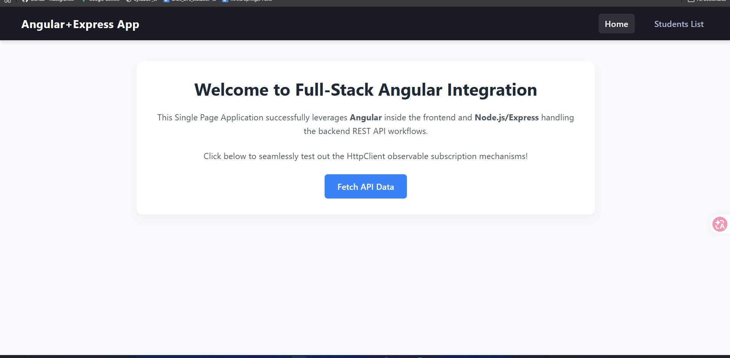
2. Students List Page – Data Fetched from Express.js API and Displayed in UI
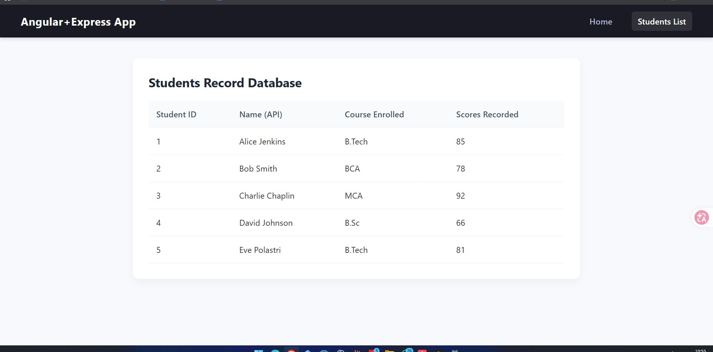

Conclusion:
In this assignment, a full-stack web application was built using Angular on the frontend and Node.js/Express.js on the backend. The Express server exposes a REST API endpoint that returns student data in JSON format. The Angular frontend uses HttpClientModule and observable subscriptions to asynchronously fetch this data and render it in a structured table displaying Student ID, Name (API), Course Enrolled, and Scores Recorded. This demonstrates end-to-end integration between an Angular SPA and an Express.js REST API.

